kırpıntı çizim, simge, sembol, grafik, tasarım içeren bir resim

Açıklama otomatik olarak oluşturuldu

MIDDLE EAST TECHNICAL UNIVERSITY

ELECTRICAL & ELECTRONICS ENGINEERING

2024-2025 FALL

EE463 – STATIC POWER CONVERSION I

HARDWARE PROJECT

SIMULATION REPORT

24.11.2024

Muhammet Kamer Taha GENÇ 2234748

Mustafa Burak ÇORUK 2442812

Öykü KAYAN 2516391

**Table of Contents**

**Introduction** 2

**Problem Definition** 3

**Topology Options** 3

**1)** **Single Phase Diode Rectifier with Buck Converter** 3

**2)** **Three Phase Diode Rectifier with Buck Converter** 5

**Topology Selection** 7

**Simulation Results** 8

**1)** **Three Phase Diode Rectifier Simulation** 8

**2)** **Buck Converter Simulation** 8

**3)** **Three Phase Diode Rectifier and Buck Converter Simulation** 8

**4)** **Controller Simulation** 8

**Component Selection** 8

**Conclusion** 8

**References** 8

**Introduction**

This project focuses on designing a DC motor drive system using a controlled rectifier to convert AC grid input into an adjustable DC output. The report evaluates two topologies: single-phase and three-phase diode rectifiers with buck converters, assessing their performance through simulations. Based on the results, the optimal topology is selected, and suitable components are identified. This simulation-based analysis lays the groundwork for future hardware implementation, ensuring the design meets performance and stability requirements before the prototyping phase.

**Problem Definition**

This project aims to design a controlled rectifier to power a DC motor by converting AC grid input (single-phase or three-phase) into adjustable DC output (up to 180 V).

**Key Requirements**:

* **Input**: Single-phase or three-phase AC (adjustable via variac)
* **Output**: Adjustable DC voltage, maximum 180 V
* **Topologies**: Options include:
* Single-phase diode rectifier + buck converter
* Three-phase diode rectifier + buck converter
* **Motor Specs**:
* Armature: 0.8 Ω, 12.5 mH
* Shunt: 210 Ω, 23 H
* Interpoles: 0.27 Ω, 12 mH

**Topology Options**

In designing a controlled rectifier to drive a DC motor, various topologies can be considered to convert the AC grid input into an adjustable DC output. The primary objective is to ensure a stable and efficient DC voltage for reliable motor operation. For this purpose, two alternative topologies are the single-phase diode rectifier with buck converter and the three-phase diode rectifier with buck converter, each with its own set of advantages and limitations. These topologies are discussed in detail below.

1. **Single Phase Diode Rectifier with Buck Converter**

In this configuration, the single-phase AC input is first rectified by the diode rectifier, converting the AC into DC, as shown in Figure 1. The output of the rectifier is then processed by the buck converter, shown in Figure 2, which steps down the DC voltage to the desired level.

diyagram, teknik çizim, çizgi, taslak içeren bir resim

Açıklama otomatik olarak oluşturuldu

Figure 1: Single Phase Diode Rectifier Circuit

The first stage of the system involves converting the AC input into DC. This is done using a single-phase diode rectifier. In a single-phase full-wave rectifier, the diodes are arranged to rectify both the positive and negative halves of the AC waveform.

The output of the rectifier is a pulsating DC voltage. The average DC output voltage, which is the DC equivalent of the rectified signal, can be calculated using the following formula:

$$V_{out}= \frac{2\sqrt{2}}{π}×V_{phase}$$

However, the output voltage is still not pure DC, as it contains ripples corresponding to the AC input frequency. These ripples may affect the performance of the motor, which is why further smoothing, and regulation are needed in the next stage.

diyagram, taslak, teknik çizim, plan içeren bir resim

Açıklama otomatik olarak oluşturuldu

Figure 2: Buck Converter Circuit

A buck converter processes the resultant DC voltage after rectification to lower it to the required level. Buck converters are an example of DC-DC converter that reduces the DC voltage. In order to create a steady, lower DC voltage, it first converts the DC input into a high-frequency pulse using a switching device. Then, inductor and capacitor filter the pulse.

The duty cycle D of the buck converter, which is the ratio of the switch's on-time to the overall switching cycle period, determines the output voltage. The output voltage formula is as follows:

$$V_{out}= D×V_{in}$$

Overall formula for the system is:

$$V_{out}=D×\frac{2\sqrt{2}}{π}×V_{phase}$$

**Advantages**

* The single-phase diode rectifier is a straightforward solution to convert AC to DC, requiring fewer components than three-phase alternatives.
* Due to fewer components, the single-phase configuration is generally cheaper to implement.
* This configuration provides a straightforward yet efficient solution for smaller motors and is ideal for low-power DC motor applications.
* With fewer diodes in the conduction path, single-phase systems experience lower voltage drops across the diodes compared to three-phase systems, leading to lower conduction losses at lower current levels.

**Disadvantages**

* There are ripples in the rectified DC output that could affect motor performance, necessitating extra filtering and regulation steps.
* Compared to three-phase rectifiers, single-phase rectifiers are less effective at higher power levels.

1. **Three Phase Diode Rectifier with Buck Converter**

This configuration involves two stages: the three-phase diode rectifier and the buck converter, working together to efficiently convert and regulate the voltage supplied to the DC motor.

diyagram, çizgi, teknik çizim, plan içeren bir resim

Açıklama otomatik olarak oluşturuldu

Figure 3: Three Phase Diode Rectifier Circuit

Each of the three sinusoidal AC waveforms in a three-phase system is 120 degrees out of phase with the others. The rectifier transforms the three-phase AC input into pulsating DC by allowing current to flow through the circuit in a single direction using six diodes placed in a bridge arrangement.

The output of the three-phase rectifier is pulsating DC, and the average DC voltage is given by:

diyagram, taslak, teknik çizim, plan içeren bir resim

Açıklama otomatik olarak oluşturuldu

Figure 4: Buck Converter Circuit

Following the three-phase diode rectifier's correction of the DC voltage, the output still requires regulation and control. A buck converter, which lowers down the DC voltage to the required level, is used to do this. The formula for the output voltage is:

$$V_{out}= D×V_{in}$$

Overall formula for the system is:

$$V_{out}=D×\frac{3\sqrt{2}}{π}×V_{linetoline}$$

**Advantages**

* The output voltage from a three-phase rectifier is higher compared to a single-phase rectifier for the same input AC voltage.
* The DC output of a three-phase rectifier is smoother than that of a single-phase rectifier because it generates less ripple. This is critical for efficient and reliable motor performance, especially at higher loads.
* By better utilizing the available AC input, the three-phase system improves efficiency and regulates the DC output. For DC motor applications, where steady power delivery is crucial, this is especially advantageous.
* Three-phase rectifiers are better for larger DC motors or applications needing larger amounts of energy production since they can manage higher power levels more effectively. Performance is enhanced and energy losses are decreased as a result.

**Disadvantages**

* Compared to the single-phase option, the three-phase diode rectifier system is more complicated. To handle the three-phase AC input, it needs more parts, including six diodes and more circuitry, which extends the design time and complicates the system.
* The system is more costly to implement due to the higher number of diodes and components.
* With more diodes in the conduction path, a three-phase full-bridge rectifier experiences greater total voltage drops across the diodes during operation.

**Topology Selection**

After carefully evaluating the advantages and disadvantages of both the single-phase diode rectifier with buck converter and the three-phase diode rectifier with buck converter, the decision was made to choose the three-phase diode rectifier with buck converter topology for the motor drive application.

**Higher Output Voltage**: The three-phase rectifier provides a higher DC output voltage, making it suitable for high-power motor applications.

**Smoother DC Output**: Compared to the single-phase rectifier, the three-phase system produces less ripple in the DC output, ensuring stable motor performance and efficiency.

**Increased Efficiency**: The three-phase system is more efficient for high-power applications, minimizing losses and improving overall system performance.

**Simulation Results**

1. **Three Phase Diode Rectifier Simulation**
2. **Buck Converter Simulation**
3. **Three Phase Diode Rectifier and Buck Converter Simulation**

**diyagram, plan, teknik çizim, şematik içeren bir resim

Açıklama otomatik olarak oluşturuldu**

Figure x. Connected circuit of three phase diode rectifier and buck converter (non-ideal conditions).

ekran görüntüsü, metin, çizgi içeren bir resim

Açıklama otomatik olarak oluşturuldu

Figure y. Phase a Input Current and Output Voltage vs Time Plot of the three phase diode rectifier.

**metin, ekran görüntüsü, yazı tipi, çizgi içeren bir resim

Açıklama otomatik olarak oluşturuldu**

Figure z. Closer perspective for input phase current and output voltage of the three-phase diode rectifier after power flow starts and circuit become stable.

**metin, ekran görüntüsü, çizgi, öykü gelişim çizgisi; kumpas; grafiğini çıkarma içeren bir resim

Açıklama otomatik olarak oluşturuldu**

Figure a. Inductance Voltage and Output Voltage and Inductance Current vs Time Plot of the buck converter.

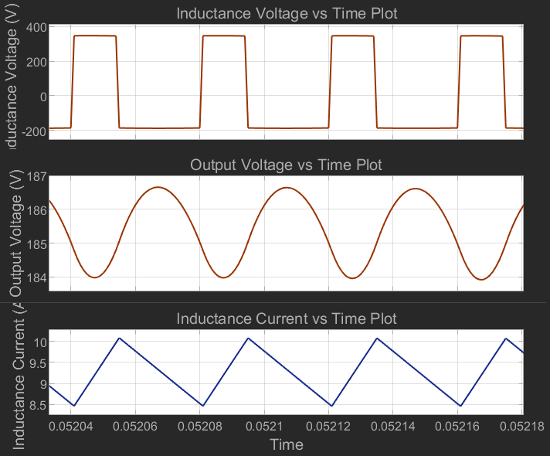

Figure b. Closer perspective for inductance voltage, output voltage and inductance current of the buck converter after power flow starts and circuit become stable.

**metin, ekran görüntüsü, yazı tipi, piyano içeren bir resim

Açıklama otomatik olarak oluşturuldu**

Figure c. Diode Voltage and Diode Current vs Time plot for the three-phase diode rectifier.

metin, ekran görüntüsü, öykü gelişim çizgisi; kumpas; grafiğini çıkarma, çizgi içeren bir resim

Açıklama otomatik olarak oluşturuldu

Figure e. Buck converter diode voltage and current vs time plot.

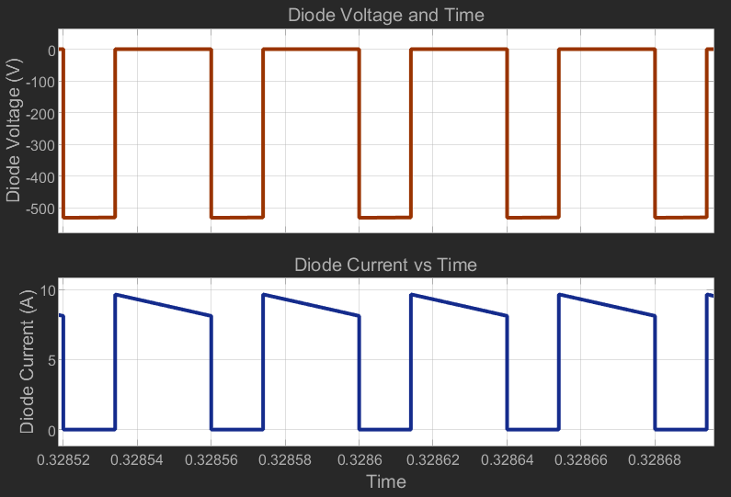

Figure d. Buck converter diode voltage and current vs time plot after circuit become stable.

1. **Controller Simulation**

**Component Selection**

**Conclusion**

**References**